Order Of Service

Singing: Psalm 47—CW page 85

Reading: Psalm 126

Opening Hymn: CW 496

Reading: Hebrews 12:25-29

Request Hymn: CW Supplement 754

Reading: Luke 17:20-37

Sermon Hymn: CW 363

Sermon Text: Song Of Solomon 1:9

Pharaoh’s Horses

Prayer

The Apostles’ Creed, TLH page 12

Holy Communion

The Lord's Prayer

The Blessing

Closing Hymn: CW 449

* * * * * * * * * * *

Bible Study: Lambs: Luke 10:25-39; Help Your Neighbor
Sheep: Proverbs 4:1-9; Your Choice
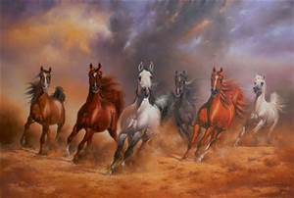

Pharaoh’s Horses

Water
Of
Life

9 August 2015

W A T E R O F L I F E

Independent Christian Church—Conservative Lutheran Doctrine

Worship Service: 9:30 a.m. Bible Study: 10:45 a.m.

Larry Cooper, Pastor E-Mail address:
111 N. Ridge Road lcooper@wateroflife.cc
Coon Valley, WI 54623 Web Site:
Phone: (608) 452-2105 www.wateroflife.cc

* * * * * * * * * * * * * * * * * * * * * * * * * * *

Sermon Text: Song Of Solomon 1:9

Pharaoh’s Chariots

* * * * * * * * * * * * * * * * * * * * * * * * * * *

9: I have compared thee, O my love, to a company of horses in Pharaoh's chariots.

Among The Trumpets

19: Hast thou given the horse strength? hast thou clothed his neck with thunder?
20: Canst thou make him afraid as a grasshopper? the glory of his nostrils is terrible.
21: He paweth in the valley, and rejoiceth in his strength: he goeth on to meet the armed men.
22: He mocketh at fear, and is not affrighted; neither turneth he back from the sword.
23: The quiver rattleth against him, the glittering spear and the shield.
24: He swalloweth the ground with fierceness and rage: neither believeth he that it is the sound of the trumpet.
25: He saith among the trumpets, Ha, ha; and he smelleth the battle afar off, the thunder of the captains, and the shouting.

Job 39:19-25

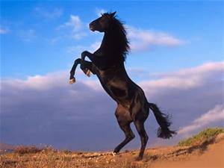

Historians tell us that Egypt was famous for having the very best horses. Solomon imported his horses from Egypt. And Pharaoh, no doubt, had the choicest of the country for his own chariots—the pick of the herd.

The Bride had complained of her own weakness, and the danger she was in of being made a prey by her enemies. The Bridegroom’s reply to her is this—“Fear not! I have made thee like a company of horses! I have put strength into thee as I have done into the horse! You can mock at fear!”

